PAGE-1

Singular Value Decomposition (SVD)

PAGE-2

Matrix Transpose:







**OPTIONAL: R code**

help(matrix)

A<-matrix(c(1,2),nrow=1,ncol=2,byrow=TRUE)

A

t(A)

B<-matrix(c(1,2,3,4),nrow=2,ncol=2,byrow=TRUE)

B

t(B)

C<matrix(c(1,2,3,4,5,6),nrow=3,ncol=2,byrow=TRUE)

C

t(C)

PAGE-3

Matrix Multiplication:









OPTIONAL R Code

A<-

matrix(c(1,2,3,4,5,6),nrow=3,ncol=2,byrow=

TRUE)

A

B<-

matrix(c(1,2,3,4,5,6,7,8),nrow=2,ncol=4,byro

w=TRUE)

B

C<-A%*%B

D<-t(B)%*%t(A) ## note, B%*%A is not

possible;

how does D look like?

AB ≠BA

PAGE-4

Matrix Inverse:

If, *A B I*,identity matrix, Then, B = A-1

Identity matrix

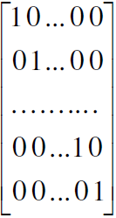

Page-5

OPTIONAL R Code

## How to create nˣn

Identity matrix?

help(diag)

A<-diag(5)

## find inverse of a matrix

solve(A)

X= UΣVT



U and V are orthonormal matrices

PAGE-6

**OPTIONAL R Code**

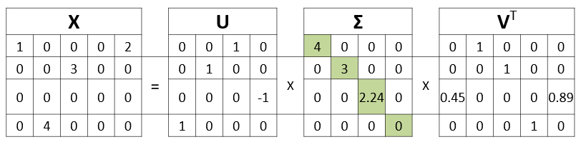

>M=matrix(c(1,0,0,0,0,0,0,4,0,3,0,0,0,0,0,0,2,0,0,0),nrow=4,ncol= 5)

> X=svd(M)

> X$u

> X$d

> X$v

> X$u%*%diag(X$d)%*%t(X$v)

**PAGE-7**

Applications of SVD in image Processing

– Closest rank-k approximation for a matrix - X

Xk = i iT

– Each term in the summation expression

above is called principal image

PAGE-8

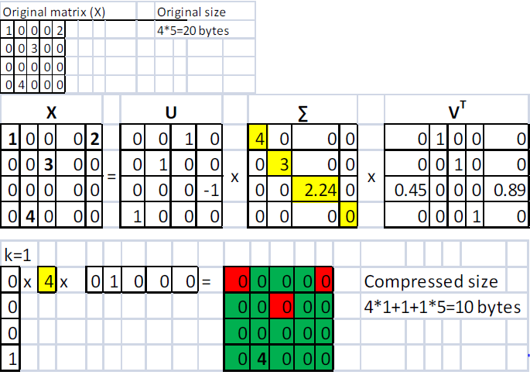

PAGE-9

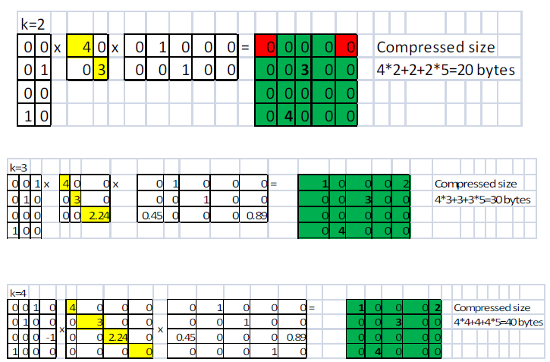

PAGE-10

The image compression example in

http://journal.batard.info/post/2009/04/08/svdfun-

profit

• Original size = 384*384 bytes = 147,456

bytes

• k=1: 384*1+1+1*384=769 bytes

• k=10: 384*10+10+10*384=7,690 bytes

• k=20: 384*20+20+20*384=15,380 bytes

• k=50: 384*50+50+50*384=38,450 bytes

• k=100: 384*100+100+100*384=76,900

bytes

• k=200: 384*200+200+200*384=153,800

bytes